WEB CONTENT

Board Members (Picture then name)

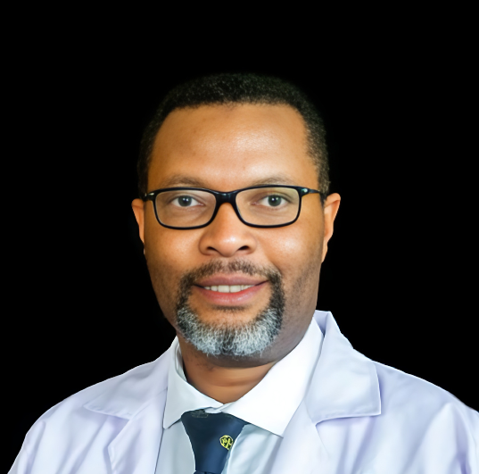
Pro. Jumaa Bwika- Honourable Chair

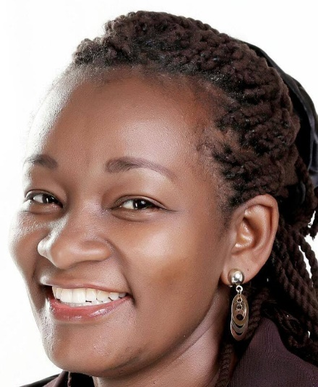
Mrs. Claire Njoki Kamu- Honourable V. Chairperson


Dr. Jacqueline Wanjiku Kagima- Honourable Secretary

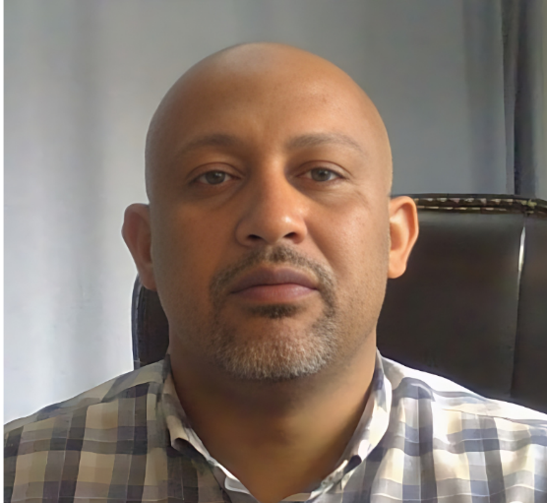
Dr. Salim Masoud- Honourable Treasurer

Dr. Newton Ang'wa- Honourable Assistant Secretary

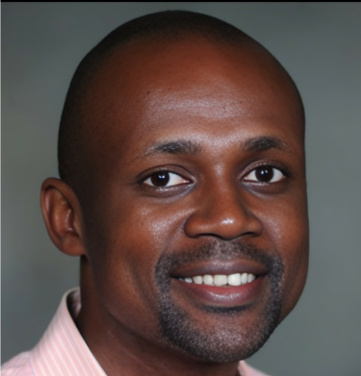
Dr. Andrew Owuor- Honourable Member

Dr.Diana Marangu- Honourable Member
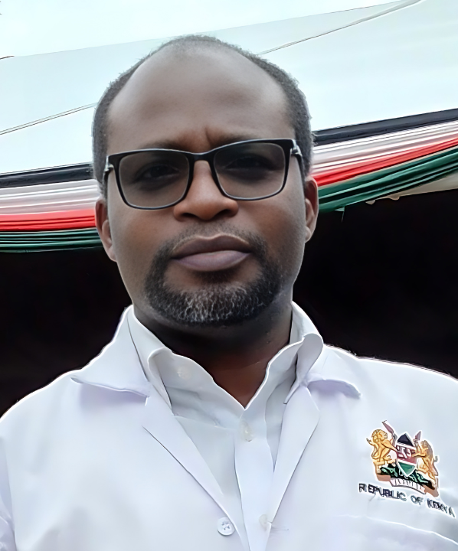
Mr. Timothy Kamau Kibe- Honourable Member

Dr. Boru Okotu-Honourable Member

